**Name: Noman Siddique**

**Roll Number: 19P1664**

**Subject: Software Design and Architecture**

**Lab Tak:14**

**Instructor: Usama Musharraf**

**Creational Design Pattern**

1. **Factory Design Pattern:**

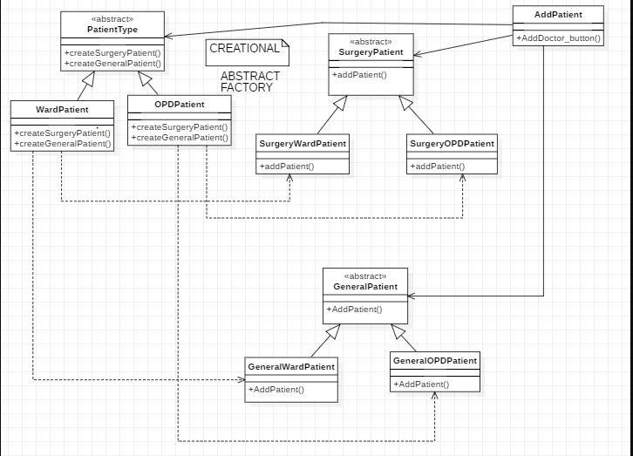We will have many classes and its objects. To create the objects of related families like Ward and OPD. We will create PatientType Class which will work as factory class and wardpatient, OPDpatient will work as concrete class. The picture is given below:

1. **Singleton Design Pattern:**

In this Design Pattern we will create single instance for a single class.

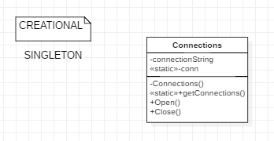

**Structural Design Pattern**

1. **Facade Pattern:**

In this interface we will provide one interface for different types of Patients. For example SurgeryPatient class for both SurgeryWardPatients and SurgeryOPDPatients.

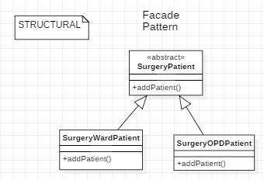

1. **Proxy Pattern:**

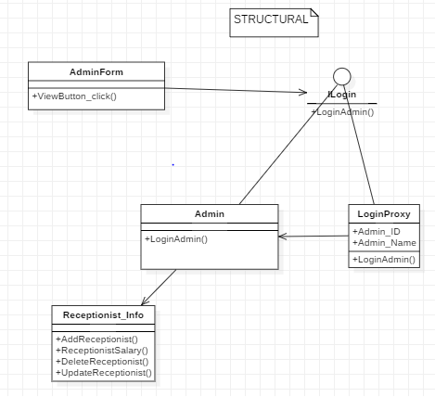In this design pattern we will hide an interface from other classes except those who have the access to it.

Like we will hide class receptionist from other classes

except admin.

**Behavioral Pattern**

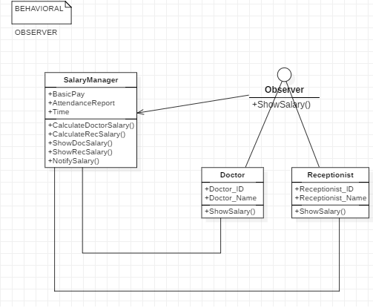

**Strategy Design Pattern**

